STAT X12: Lab Assignment #5
Clair Haags, Ben Heinze, Charlie Metzer
Due Wednesday, 3/4/26, 8am

Part I: grazer contrasts wrap up
For this part of the lab you will need to use the seaweed grazer data, case1301 in Sleuth3 to address questions (1) and (2) below. Although you can set up the contrasts without looking at the data, you’ll need to (1) transform the Cover variable to create the “logit-regeneration ratio” response variable, (2) fit the final inferential model (in this case that is the additive model), (3) write code to estimate contrasts and generate 95% CIs for the true contrast, and (4) write up a summary of statistical findings on the odds/“regeneration ratio” scale.
# load packages
library(tidyverse)
library(Sleuth3)
library(ggeffects)
library(effects)
library(multcomp)
library(yarrr)
library(emmeans)
# seaweed grazer data
glimpse(case1301)
## Rows: 96
## Columns: 3
## $ Cover <int> 14, 23, 22, 35, 67, 82, 94, 95, 34, 53, 58, 75, 19, 47, 53, 61, …
## $ Block <fct> B1, B1, B2, B2, B3, B3, B4, B4, B5, B5, B6, B6, B7, B7, B8, B8, …
## $ Treat <fct> C, C, C, C, C, C, C, C, C, C, C, C, C, C, C, C, L, L, L, L, L, L…
- Specify, analyze, and write up results from the contrast that allows you to investigate. Your summary should include a description of the contrast, a hypothesis test, and an interpretation of the 95% CI for the contrast of interest. Do small fish have an effect on the regeneration ratio? If so, how much?
df_grazers_logit <- case1301 |>
mutate(CoverLogit = log(Cover/(100-Cover)))
lm_add <- lm(CoverLogit ~ Treat + Block, data=df_grazers_logit)
levels(case1301$Treat)
## [1] "C" "L" "Lf" "LfF" "f" "fF"
emm_grazers_logit <- emmeans(lm_add, specs = ~Treat)
f_int <- c(-.5, -.5, .5, 0, .5, 0)
gam2 <- contrast(emm_grazers_logit, list(gamma2 = f_int))
gam2
## contrast estimate SE df t.ratio p.value
## gamma2 -0.393 0.15 83 -2.627 0.0103
##
## Results are averaged over the levels of: Block
confint(gam2)
## contrast estimate SE df lower.CL upper.CL
## gamma2 -0.393 0.15 83 -0.691 -0.0955
##
## Results are averaged over the levels of: Block
## Confidence level used: 0.95
To create the contrast, we need to analyze the possible ways to isolate the effect of small fish on the regeneration ratio. There are two possible ways, shown in the equation below.
$$γ_{2}=\frac{1}{2}\left(μ_{Lf}-μ_{L}\right)+\frac{1}{2}\left(μ_{f}-μ_{C}\right)$$
Our null hypothesis is that small fish do not have an effect on the regeneration ratio. The alternative hypothesis is that small fish have some effect on the regeneration ratio. We are 95% confident that the median odds of regeneration associated with the presence of small fish is between 0.5011 and 0.9089 times that of the regeneration ratio without small fish.
- Specify, analyze, and write up results from the contrast that allows you to investigate. Your summary should include a description of the contrast, a hypothesis test, and an interpretation of the 95% CI for the contrast of interest. Do limpets have an effect on the regeneration ratio? If so, how much?
f_int2 <- c((-1/3), (1/3), (1/3), (1/3), (-1/3), (-1/3))
gam3 <- contrast(emm_grazers_logit, list(gamma3 = f_int2))
gam3
## contrast estimate SE df t.ratio p.value
## gamma3 -1.83 0.122 83 -14.961 <0.0001
##
## Results are averaged over the levels of: Block
confint(gam3)
## contrast estimate SE df lower.CL upper.CL
## gamma3 -1.83 0.122 83 -2.07 -1.59
##
## Results are averaged over the levels of: Block
## Confidence level used: 0.95
To create the contrast, we need to analyze the possible ways to isolate the effect of small fish on the regeneration ratio. There are three possible ways, shown in the equation below.
$$γ_{3}=\frac{1}{3}\left(μ_{LfF}-μ_{fF}\right)+\frac{1}{3}\left(μ_{Lf}-μ_{f}\right)+\frac{1}{3}\left(μ_{L}-μ_{C}\right)$$
Our null hypothesis is that small fish do not have an effect on the regeneration ratio. The alternative hypothesis is that small fish have some effect on the regeneration ratio. We are 95% confident that the median odds of regeneration associated with the presence of small fish is between 0.126 and 0.204 times that of the regeneration ratio without small fish.

Part II: More practice and other follow-up tests
We will use ex1321 in Sleuth3: “A data set simulated to match the summary statistics and conclusions from Rosenthal and Jacobson’s Pygmalion study on elementary school students. The researchers assigned students at random to a Pygmalion or control treatment group. They supplied information to the teachers of those in the Pygmalion group with the false information that an intelligence test had indicated that the student was likely to excel.” Student participants were given a standardized “intelligence” test at the beginning and end of the school year and their gain (post-pre) test was recorded. This was done for grades 1-6.
- Rosenthal, R. and Jacobson, L. 1968, Pygmalion in the Classroom: Teacher Expectation and Pupil’s Intellectual Development, Holt, Rinehart, and Winston, Inc.
# rename data
df_pyg <- ex1321
#Converted grade to a categorical variable for raw data plot
df_pyg$Grade_fact <- as.factor(df_pyg$Grade)
glimpse(df_pyg)
## Rows: 320
## Columns: 6
## $ Student <int> 1, 2, 3, 4, 5, 6, 7, 8, 9, 10, 11, 12, 13, 14, 15, 16, 17, …
## $ Grade <int> 1, 1, 1, 1, 1, 1, 1, 1, 1, 1, 1, 1, 1, 1, 1, 1, 1, 1, 1, 1,…
## $ Class <fct> 1a, 1a, 1a, 1a, 1a, 1a, 1a, 1a, 1a, 1a, 1a, 1a, 1a, 1a, 1a,…
## $ Treatment <fct> control, control, control, control, control, control, contr…
## $ Gain <int> -4, 0, -19, 24, 19, 10, 5, 10, 29, 13, -9, -8, 20, -1, 12, …
## $ Grade_fact <fct> 1, 1, 1, 1, 1, 1, 1, 1, 1, 1, 1, 1, 1, 1, 1, 1, 1, 1, 1, 1,…
- Write out a two-way ANOVA model that allows you to investigate the Pygmalian effect on mean gain score and if this relationship is different for different grade levels. Use the following variable definitions, and don’t forget the model for the variance around the group means!
- Define $I_{g}$ = 1 if student is in group g, and 0 if student is not in group g for $g=G1,G2,G3,G4,G5,G6$
- Define $I_{trt}=1$ if student is in treatment group trt, and 0 if student is not in treatment group trt, where $trt=Pygmalian,Control$.
- Gain = gain score on standardized “intelligence” test (post-pre) in points.
$$\hat{μ}\{\text{Gain}∣\text{ Grade, Treatment}\}=β_{0}+β_{1}I_{G2}+β_{2}I_{G3}+β_{3}I_{G4}+β_{4}I_{G5}+β_{5}I_{G6}+β_{6}I_{Control}\text{ add variance later}$$
- Create a raw data display and interaction plot for these data that allows you to investigate the Pygmalian effect on gain score, and if this relationship is different for the different grade levels studied. Provide a brief description of each plot with respect to how the plot helps you informally assess model assumptions or the presence of an interaction.
ggplot(df_pyg, aes(x = Grade_fact, y = Gain)) +
geom_violin() +
geom_jitter(aes(color = Treatment), width = 0.2, size = 1.5, alpha = 0.5)
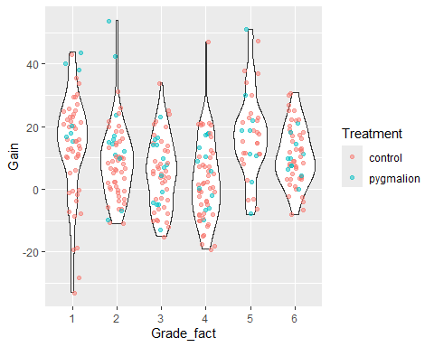
The violin plots do suggest the intelligence test score gain is roughly similar across all grade levels. The Pygmalion treatment group appeas to be slightly higher on average than the control group for first graders and second graders, but they are spread out evenly across grades three through six.
- Fit the saturated model and create residual diagnostics. Assuming there are no severe violations of the independence assumption, do the residual diagnostics suggest any severe violations of other TWA modeling assumptions? Briefly explain your answer.
lm_int <- lm(Gain ~ Grade_fact*Treatment, data= df_pyg)
par(mfrow = c(2,2))
plot(lm_int, pch = 18)
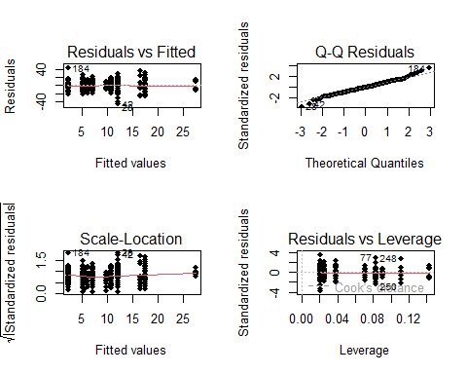
No, there does not appear to be any severe violations across any other assumptions.
- Regardless of your answer to the previous question, conduct a hypothesis test that allows you to investigate if the Pygmalion effect depends on grade level. Write a summary of statistical findings for your test. Note there are two ways you can approach this problem!
lm_int <- lm(Gain ~ Grade_fact*Treatment, data= df_pyg)
anova(lm_int)
## Analysis of Variance Table
##
## Response: Gain
## Df Sum Sq Mean Sq F value Pr(>F)
## Grade_fact 5 6992 1398.37 8.8836 6.797e-08
## Treatment 1 930 930.22 5.9095 0.01563
## Grade_fact:Treatment 5 1505 301.01 1.9122 0.09201
## Residuals 308 48482 157.41
confint(lm_int)
## 2.5 % 97.5 %
## (Intercept) 8.4783533 15.6049801
## Grade_fact2 -10.1502398 -0.0181999
## Grade_fact3 -12.2519146 -1.6814188
## Grade_fact4 -14.8102783 -4.7832591
## Grade_fact5 -0.6300947 11.3929152
## Grade_fact6 -6.4309191 3.8142525
## Treatmentpygmalion 5.3987251 25.3750845
## Grade_fact2:Treatmentpygmalion -18.6318415 6.9431384
## Grade_fact3:Treatmentpygmalion -27.0529191 -1.8708904
## Grade_fact4:Treatmentpygmalion -24.8985807 0.6349753
## Grade_fact5:Treatmentpygmalion -29.1830311 -1.5480434
## Grade_fact6:Treatmentpygmalion -29.2910282 -3.3130844
There is little evidence against the null hypothesis that there is no effect of the Pygmalion effect between grade levels. (anova test, F=1.9211, p-val = 0.09201)
- Regardless of your answer to the previous question, suppose the researchers believe the Pygmailon effect should depend on grade level. Create an effects plots summarizing the most appropriate model in this case. Reference Display 13.21 and the discussion around “unpacking non-additive relationships” and provide a description of how grade and treatment interact in the context of this study.
plot(effect("Grade_fact:Treatment", lm_int))
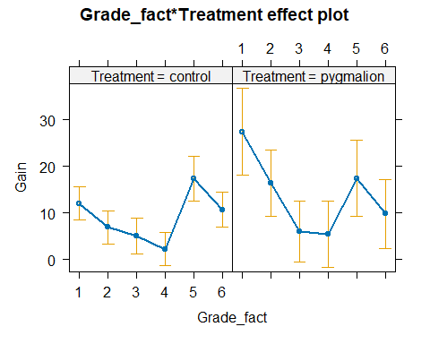
#library(ggeffects)
#plot(ggpredict(lm_int, terms=c("Grade_fact", "Treatment"))) +
# geom_line(lty=2)
Although there is a low interaction overall between the Pygmalion effect and which school grade on intelligence test scores, the effects plot illustrate that there is a much higher gain on intelligence test scores for first and second graders, then the effect diminishes from third grade to sixth grade. This suggests that first and second graders are more susceptible to the Pygmalion effect, but this susceptibility fades as the children progress through school.
- Generally, in the presence of an interaction, contrasts and linear combinations of marginal means of a single factor are useless. Comparing the marginal mean response between levels of factor A that are averaged over factor B (or visa versa) does not make sense because the relationship between the response and levels of factor A depends on the level of factor B! We can, however conduct contrasts on a flattened interaction variable that generates a level for every cell mean in the two-way table (most interesting). Or, we can investigate all pairwise comparisons of cell means (a bit lazy and not as interesting). We will choose the lazy route here. Walk through the code line-by-line discussing each step with your group. To answer this question, summarize what you learn about differences between the 12 groups from this “all-pairwise comparisons” Tukey HSD follow-up test.
# create a flattened treatment variable with 12 levels
df_flat <- df_pyg |>
mutate(flat_trt = factor(interaction(Grade, Treatment)))
# plot the raw data
pirateplot(Gain ~ flat_trt, data = df_flat,
inf.method = "ci", inf.disp = "line", pal = "gray")
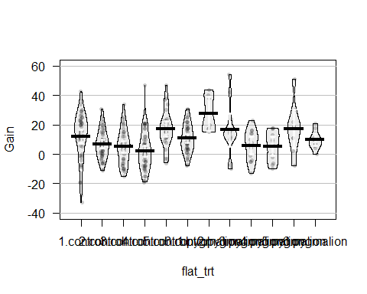
# fit a one-way ANOVA with the flattened trt variable
pyg_oneway <- lm(Gain ~ flat_trt, data = df_flat)
# take a look at results
summary(pyg_oneway)$coefficients
## Estimate Std. Error t value Pr(>|t|)
## (Intercept) 12.041667 1.810906 6.6495244 1.339179e-10
## flat_trt2.control -5.084220 2.574595 -1.9747650 4.918768e-02
## flat_trt3.control -6.966667 2.686008 -2.5936876 9.948883e-03
## flat_trt4.control -9.796769 2.547909 -3.8450236 1.464733e-04
## flat_trt5.control 5.381410 3.055098 1.7614523 7.915402e-02
## flat_trt6.control -1.308333 2.603342 -0.5025591 6.156334e-01
## flat_trt1.pygmalion 15.386905 5.076079 3.0312581 2.642105e-03
## flat_trt2.pygmalion 4.458333 4.049310 1.1010106 2.717517e-01
## flat_trt3.pygmalion -6.041667 3.810903 -1.5853637 1.139099e-01
## flat_trt4.pygmalion -6.541667 4.049310 -1.6155016 1.072260e-01
## flat_trt5.pygmalion 5.402778 4.557348 1.1855092 2.367300e-01
## flat_trt6.pygmalion -2.223485 4.193974 -0.5301619 5.963817e-01
# what does this one-way ANOVA tell us? Discuss with your group
anova(pyg_oneway)
## Analysis of Variance Table
##
## Response: Gain
## Df Sum Sq Mean Sq F value Pr(>F)
## flat_trt 11 9427 857.01 5.4444 6.248e-08
## Residuals 308 48482 157.41
# conduct Tukey HSD procedure to compare all
# pairwise comparisons of means: note there are choose(12,2) = 66 comparisons!
# generate family-wise 95% CIs (using studentized range dist'n to adjust multiplier
pyg_pairs <- glht(pyg_oneway, linfct = mcp(flat_trt = "Tukey"))
summary(pyg_pairs)
##
## Simultaneous Tests for General Linear Hypotheses
##
## Multiple Comparisons of Means: Tukey Contrasts
##
##
## Fit: lm(formula = Gain ~ flat_trt, data = df_flat)
##
## Linear Hypotheses:
## Estimate Std. Error t value Pr(>|t|)
## 2.control - 1.control == 0 -5.08422 2.57459 -1.975 0.6841
## 3.control - 1.control == 0 -6.96667 2.68601 -2.594 0.2643
## 4.control - 1.control == 0 -9.79677 2.54791 -3.845 <0.01
## 5.control - 1.control == 0 5.38141 3.05510 1.761 0.8183
## 6.control - 1.control == 0 -1.30833 2.60334 -0.503 1.0000
## 1.pygmalion - 1.control == 0 15.38690 5.07608 3.031 0.0932
## 2.pygmalion - 1.control == 0 4.45833 4.04931 1.101 0.9934
## 3.pygmalion - 1.control == 0 -6.04167 3.81090 -1.585 0.9016
## 4.pygmalion - 1.control == 0 -6.54167 4.04931 -1.616 0.8894
## 5.pygmalion - 1.control == 0 5.40278 4.55735 1.186 0.9878
## 6.pygmalion - 1.control == 0 -2.22348 4.19397 -0.530 1.0000
## 3.control - 2.control == 0 -1.88245 2.69897 -0.697 0.9999
## 4.control - 2.control == 0 -4.71255 2.56156 -1.840 0.7729
## 5.control - 2.control == 0 10.46563 3.06650 3.413 0.0306
## 6.control - 2.control == 0 3.77589 2.61671 1.443 0.9467
## 1.pygmalion - 2.control == 0 20.47112 5.08295 4.027 <0.01
## 2.pygmalion - 2.control == 0 9.54255 4.05792 2.352 0.4140
## 3.pygmalion - 2.control == 0 -0.95745 3.82005 -0.251 1.0000
## 4.pygmalion - 2.control == 0 -1.45745 4.05792 -0.359 1.0000
## 5.pygmalion - 2.control == 0 10.48700 4.56500 2.297 0.4514
## 6.pygmalion - 2.control == 0 2.86074 4.20228 0.681 0.9999
## 4.control - 3.control == 0 -2.83010 2.67352 -1.059 0.9953
## 5.control - 3.control == 0 12.34808 3.16062 3.907 <0.01
## 6.control - 3.control == 0 5.65833 2.72640 2.075 0.6127
## 1.pygmalion - 3.control == 0 22.35357 5.14028 4.349 <0.01
## 2.pygmalion - 3.control == 0 11.42500 4.12950 2.767 0.1808
## 3.pygmalion - 3.control == 0 0.92500 3.89600 0.237 1.0000
## 4.pygmalion - 3.control == 0 0.42500 4.12950 0.103 1.0000
## 5.pygmalion - 3.control == 0 12.36944 4.62875 2.672 0.2235
## 6.pygmalion - 3.control == 0 4.74318 4.27145 1.110 0.9929
## 5.control - 4.control == 0 15.17818 3.04413 4.986 <0.01
## 6.control - 4.control == 0 8.48844 2.59046 3.277 0.0464
## 1.pygmalion - 4.control == 0 25.18367 5.06948 4.968 <0.01
## 2.pygmalion - 4.control == 0 14.25510 4.04104 3.528 0.0216
## 3.pygmalion - 4.control == 0 3.75510 3.80211 0.988 0.9974
## 4.pygmalion - 4.control == 0 3.25510 4.04104 0.806 0.9996
## 5.pygmalion - 4.control == 0 15.19955 4.55000 3.341 0.0380
## 6.pygmalion - 4.control == 0 7.57328 4.18599 1.809 0.7913
## 6.control - 5.control == 0 -6.68974 3.09067 -2.164 0.5472
## 1.pygmalion - 5.control == 0 10.00549 5.34242 1.873 0.7522
## 2.pygmalion - 5.control == 0 -0.92308 4.37856 -0.211 1.0000
## 3.pygmalion - 5.control == 0 -11.42308 4.15907 -2.747 0.1894
## 4.pygmalion - 5.control == 0 -11.92308 4.37856 -2.723 0.2002
## 5.pygmalion - 5.control == 0 0.02137 4.85225 0.004 1.0000
## 6.pygmalion - 5.control == 0 -7.60490 4.51268 -1.685 0.8582
## 1.pygmalion - 6.control == 0 16.69524 5.09757 3.275 0.0467
## 2.pygmalion - 6.control == 0 5.76667 4.07622 1.415 0.9536
## 3.pygmalion - 6.control == 0 -4.73333 3.83948 -1.233 0.9834
## 4.pygmalion - 6.control == 0 -5.23333 4.07622 -1.284 0.9772
## 5.pygmalion - 6.control == 0 6.71111 4.58127 1.465 0.9409
## 6.pygmalion - 6.control == 0 -0.91515 4.21996 -0.217 1.0000
## 2.pygmalion - 1.pygmalion == 0 -10.92857 5.96697 -1.832 0.7781
## 3.pygmalion - 1.pygmalion == 0 -21.42857 5.80782 -3.690 0.0125
## 4.pygmalion - 1.pygmalion == 0 -21.92857 5.96697 -3.675 0.0127
## 5.pygmalion - 1.pygmalion == 0 -9.98413 6.32276 -1.579 0.9041
## 6.pygmalion - 1.pygmalion == 0 -17.61039 6.06607 -2.903 0.1299
## 3.pygmalion - 2.pygmalion == 0 -10.50000 4.93570 -2.127 0.5743
## 4.pygmalion - 2.pygmalion == 0 -11.00000 5.12202 -2.148 0.5592
## 5.pygmalion - 2.pygmalion == 0 0.94444 5.53241 0.171 1.0000
## 6.pygmalion - 2.pygmalion == 0 -6.68182 5.23713 -1.276 0.9783
## 4.pygmalion - 3.pygmalion == 0 -0.50000 4.93570 -0.101 1.0000
## 5.pygmalion - 3.pygmalion == 0 11.44444 5.36038 2.135 0.5693
## 6.pygmalion - 3.pygmalion == 0 3.81818 5.05506 0.755 0.9998
## 5.pygmalion - 4.pygmalion == 0 11.94444 5.53241 2.159 0.5507
## 6.pygmalion - 4.pygmalion == 0 4.31818 5.23713 0.825 0.9995
## 6.pygmalion - 5.pygmalion == 0 -7.62626 5.63916 -1.352 0.9664
## (Adjusted p values reported -- single-step method)
# plot results, discuss what you see with your group.
old.par <- par(mai = c(1.5,2,1,1))
plot(confint(pyg_pairs))
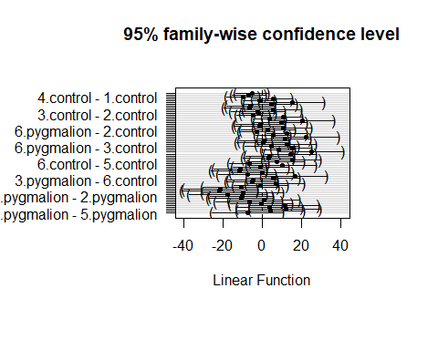
# maybe the cld will help us put what we're seeing here into words.
# you can add these letters to the effects plot you created in 7
# to help put into words what is learned from this investigation.
cld(pyg_pairs)
## 1.control 2.control 3.control 4.control 5.control 6.control
## "ab" "bc" "bc" "c" "ad" "bd"
## 1.pygmalion 2.pygmalion 3.pygmalion 4.pygmalion 5.pygmalion 6.pygmalion
## "a" "ab" "bcd" "bcd" "ab" "abc"
# let's put the letters on an effects plot
cld_label <- cld(pyg_pairs)$mcletters$Letters
# create df for cld letters
df_cld <- df_flat |>
group_by(flat_trt) |>
summarise(avg_gain = mean(Gain), n = n()) |>
mutate(cld = cld_label)
# create effects plot and add cld letters
plot(ggpredict(pyg_oneway, terms = c("flat_trt"))) +
labs(title = "Predicted values of Gain Scores and CLD ouptut",
x = "",
y = "Gain (post-pre in points)") +
geom_label(data = df_cld,
mapping = aes(x = as.numeric(flat_trt), y = avg_gain,
label = cld_label))
